SMITH’S CASTLE
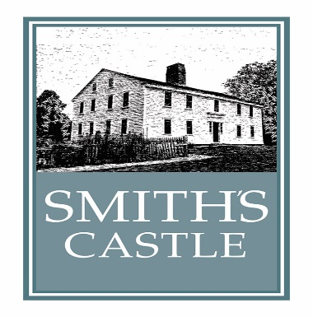
55 RICHARD SMITH DRIVE, NORTH KINGSTOWN, RI 02852
401-294-3521; smithscastle55@gmail.com; www.smithscastle.org
School/Group Tour with Activity Contact

Thank you for your interest in our programs! Allow approximately 1 ½ to 2 hours on premises for most programs. The grounds are perfect for picnics before or after the presentation. Please bring blankets and carry out trash. Groups of 40 or less can bring bag lunches to eat in our meeting room and colonial kitchen during inclement weather. On-site programs are held from mid-April to early December. Trunk shows all year.
Fees for standard programs: (Prices effective through December 31, 2016)
$6 per student for tour plus craft** All aides and teachers are free;
$5 per extra adult visitor/chaperone (one adult per 10 students free);
$5 per student for trunk show during which docents visit your class bringing historical artifacts;
**craft options include butter making (then served on baguette slices), Native American bead bag; colonial classroom simulation with quill pen writing, paper quilt patterning, take-home vegetable and herb seed planting. Additional activities can be discussed with Teacher/Coordinator prior to day of visit.

School/group name: _____________________________________________________________________________
Address: _______________________________________________________________________________________
Teacher/Coordinator name: _______________________________________________________________________
Contact info (most direct) Phone: ________________ E-mail: ____________________________________________
Grade/age of visitors: __________________ Number of visitors: __________________________________
Date of visit: ___________________________________ Arrival time: __________ Departure: __________________
Picnic/lunch on grounds? Yes _________ No __________
Do you want the Gift Shop open for your visit? Yes_______ No __________
A 1/3 deposit 2 weeks prior to your visit would be appreciated; however, we understand that that may not be feasible in some cases.
Please inform us of any in your group with food allergies (for butter making) or disabilities. We will make every attempt to accommodate these issues.
For office use:
Total fee paid: ________________ Date received: _____________
Names of docents involved in program: _____________________________________________________________________
_______________________________________________________________________________________________________

